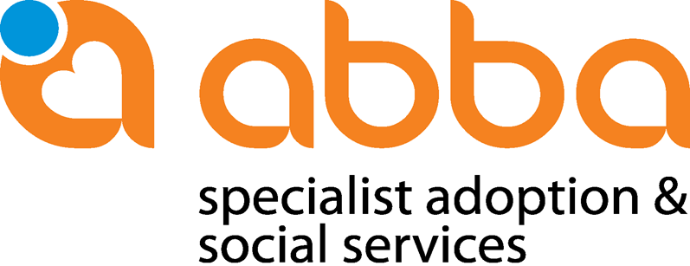

POLICY AND PROCEDURE:
HOLIDAY VISITS, OFFICIAL ROOTS VISITS AND ORIGIN ENQUIRIES

We want to differentiate between the following categories of Roots and visits to country of origin:

- Holiday visits to the country:
South Africa is a tourist friendly country and therefor families often return after the adoption to spend time in the country of origin. Parents do not have to inform Abba or your mediation organization of these holidays as it does not entail any adoption related matter. A visit to South Africa does not necessarily have to involve a visit to the Child and Youth Care Centre.

- Official Roots Visits to the country of birth, also combining it with adoption related matters:
When planning such a visit, Break-away or Roundabout could assist with your traveling needs. These visits do not really focus on the adoption process, although visits to the Child and Youth Care Centre could be arranged when possible.

These visits are seen as official roots visits, and needs to be communicated to your mediation organization for record purposes

- Origin enquiries Visits:
According to South African Legislation only allowed after the child reached the age of 18. See section 248 of the Children’s Act below:

4. Access to adoption register
(1) The information contained in the adoption register may not be disclosed to any person, except—
(a) to an adopted child after the child has reached the age of 18 years;
(b) to the adoptive parent of an adopted child after the child has reached the age of 18 years;
(c) to the biological parent or a previous adoptive parent of an adopted child after the child has reached the age of 18 years, but only if the adoptive parent and the adopted child give their consent in writing;
(d) for any official purposes subject to conditions determined by the Director General;
(e) by an order of court, if the court finds that such disclosure is in the best interests of the adopted child; or
(f) for purposes of research: Provided that no information that would reveal the identity of an adopted child or his or her adoptive or biological parent is revealed.
(2) The Director-General may require a person to receive counselling before disclosing any information contained in the adoption register to that person in terms of subsection (1) (a), (b), (c) or (e).
(3) Notwithstanding subsection (1), an adopted child or an adoptive parent is entitled to have access to any medical information concerning—
(a) the adopted child; or
(b) the biological parents of the adopted child, if such information relates directly to the health of the adopted child.
(4) Notwithstanding subsection (1), parties to a post-adoption agreement as contemplated in section 234 are entitled to have access to such information about the child as has been stipulated in the agreement.
These visits are seen as official roots visits, and needs to be communicated to your mediation organization for record purposes

Abba recommends that the following procedures are followed for any official roots visits or origin enquiries by adoptive parents after the adoption:
- Official Roots visits: Before the child is 18 years old

- Adoptive Parents inform the contract partner who will inform Abba of their wish to visit.

- Parents to complete Post Adoption Service Notice and mail to Abba representative and Break-away/Roundabout Travel (Form electronically attached). To help with planning, parents should give notice at least two month prior to planned visit.

- Break-away/Roundabout will coordinate any official liaising within the formal adoption system or role players that relates to the adoption process, i.e. visit to baby home, meet Abba staff/caregivers, area where child was born etc.

- Break-away/Roundabout can also assist with travel and accommodation needs or arrangements if needed: www.break-away.co.za, www.roundabouttours.co.za

- Origin Enquiries: Adoptee over the age of 18 years

- These enquiries are legislated by the Children’s Act, Act 38 of 2005, Section 248
- The official records can only accessed after the child turned 18 years old and should be on request of the adoptee.
- Due to the complexity, intensive preparation and availability of staff, Abba needs to be informed at least 6 months before you are planning to travel.
- Origin visits needs to be arranged via your mediation organization that will in their turn contact Abba and Breakaway/Roundabout to arrange –parents to complete Post Adoption Service notice attached. Please provide details of your origin and tourism needs, dates and availability.
- Adoptees and their parents as well as the biological family need to receive counseling in preparation of a meeting.
- In the case where the birth family is traceable and willing to meet the adoptee, counseling will be done separately initially before the child meets the biological family.
- In our experience, adoption related matters (2 to 3 days) should be planned in the beginning of the trip, to allow more time and also have flexibility should schedule appointments need to be moved around availability of biological family.

Conclusion:

What is important to understand is that your child might experience emotions and feelings related to his time growing up in South Africa - a particular smell or something else can bring out memories (good and bad) that are not expected. It might awaken questions about background and biological families that was not there before. Also be careful with a bit older children.

Depending on the age and needs of the adoptee, Abba will plan the visits in accordance with Break-away (All areas in SA) or Roundabout (Cape Town). It is therefore important to provide as much as possible information regarding your proposed trip, both regarding origin and tourism needs.

Adoptive parents are further encouraged to familiarize themselves with South Africa and its people during their stay in order to understand the culture and challenges of the birth country of their child.

As part of your travel preparation you are also welcome to visit our official website and contact the following persons:

Rene Ferreira – Head Office – rene@abbaadoptions.co.za

Tilda Fick – Western Cape – tilda@abbaadoptionwc.co.za

